  What does the School Age Immunisation Service do?
  Our aim is to offer all Dorset school aged children the protection they need by providing the recommended vaccinations as per UK schedule.
  Vaccinations are available from Reception to Year 11 and up to age 25 in Specialist school provisions.
  Contact Us:
  Tel: 01425 891162
  Email: dhc.immsenquiries@nhs.net
  Visit us on the Web:
  www.dorsethealthcare.nhs.uk
  Are your child’s vaccines
  up to date? Scan the QR
  code to check the schedule
  Dorset School Age
  Immunisation Service
  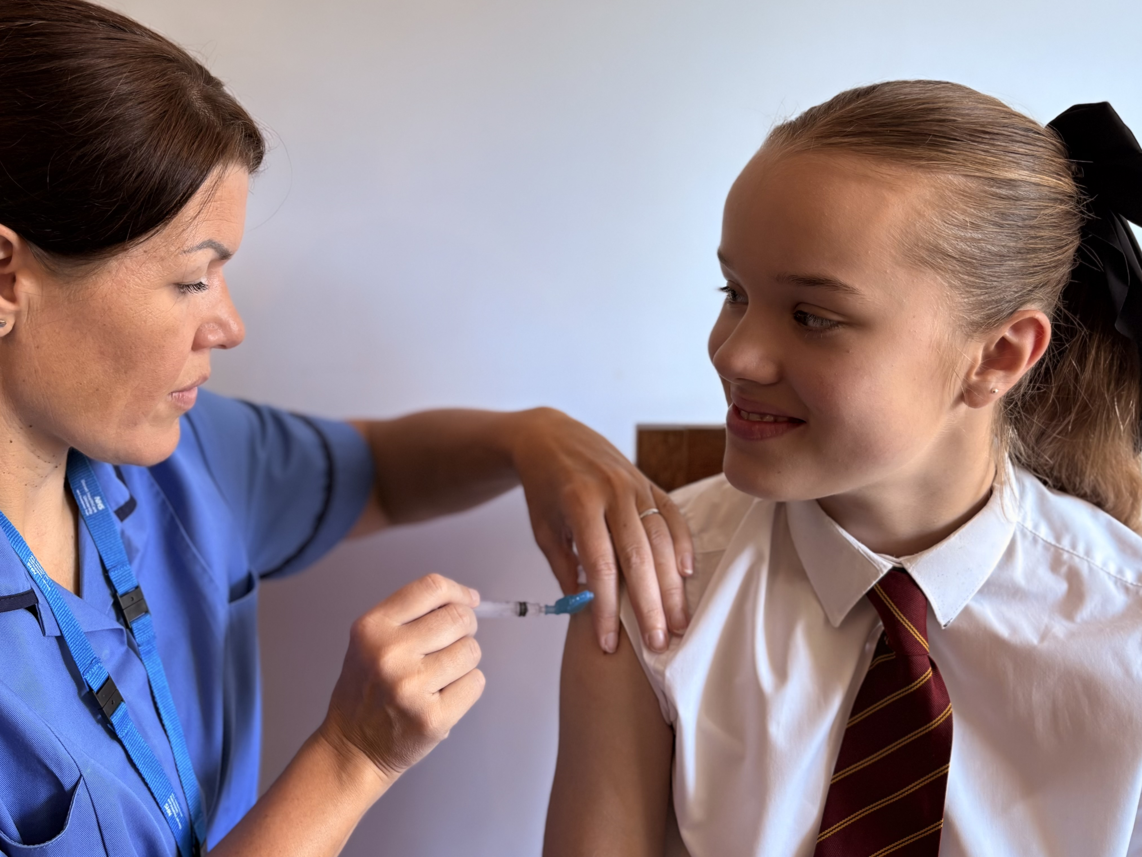
  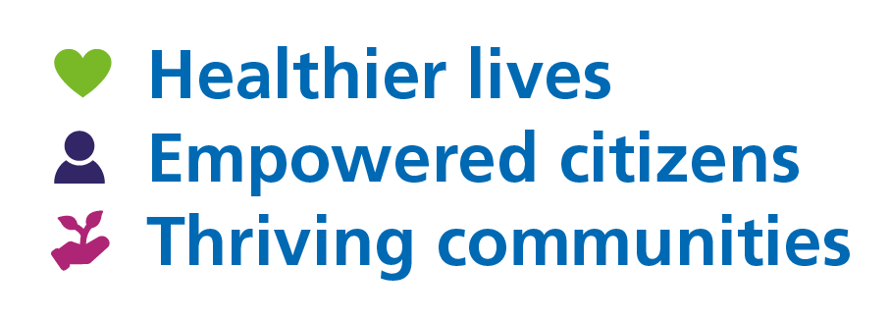
  

 |  |  | What are these vaccinations for?
  Which vaccinations do we provide and when?
  Tetanus/Diphtheria/Polio (Td/IPV)
  Td/IPV Final Booster is offered from Year 9 to Year 11
  Meningitis (MenACWY)
  MenACWY Final Booster is offered from Year 9 to Year 11
  Human Papillomavirus (HPV)
  HPV is a once only dose and is offered from Year 8 to Year 11
  Influenza (flu)
  Flu is offered yearly from Reception to Year 11
  Measles Mumps Rubella (MMR)
  
  We offer the MMR vaccine to children who missed any of their two doses during their early years. Please contact us if you think your child may require this vaccine.
  Influenza (flu)
  The flu vaccine can protect children against seasonal influenza.
  The live nasal vaccine is given as a single spray up each nostril. An inactivated flu injection is available for those children where the live vaccine is not recommended.
  Tetanus/Diphtheria/Polio (Td/IPV)
  The Td/IPV vaccine, also known as the teenage booster, is given to increase protection against three diseases – tetanus, diphtheria and polio.
  Meningitis ACWY (MenACWY)
  The MenACWY vaccine protects against four common groups of meningococcal disease – A,C,W &Y.
  Human Papillomavirus (HPV)
  The HPV vaccine helps protect both boys and girls against human papillomavirus (HPV). This virus increases the risk of developing some cancers, such as: 90 % of cervical and anal cancers, some mouth, throat and cancers of the genital areas.
  Measles/Mumps/Rubella (MMR)
  The MMR vaccine helps protect children against Measles, Mumps and Rubella.
  How do I get my child vaccinated?
  Please complete an online consent form by the requested date, using the link sent from your child’s school. If you do not complete your consent form by this date your child may not be vaccinated on the day we are in school. Please use the unique school code to consent which is provided on the offer letter.
  Home Educated children’s parent and carers will receive their link through their Local Council to book into a community clinic.
  You will receive an email from us to confirm the date of your child’s vaccination. If you have consented outside of the cutoff date or your child is absent, you will receive a link to book a community clinic.
  One of our team may contact you to gain further information if required. Please return any contact as soon as possible to avoid a delay in your child’s vaccination.
  in the email to choose and book.?? choose a clinic

