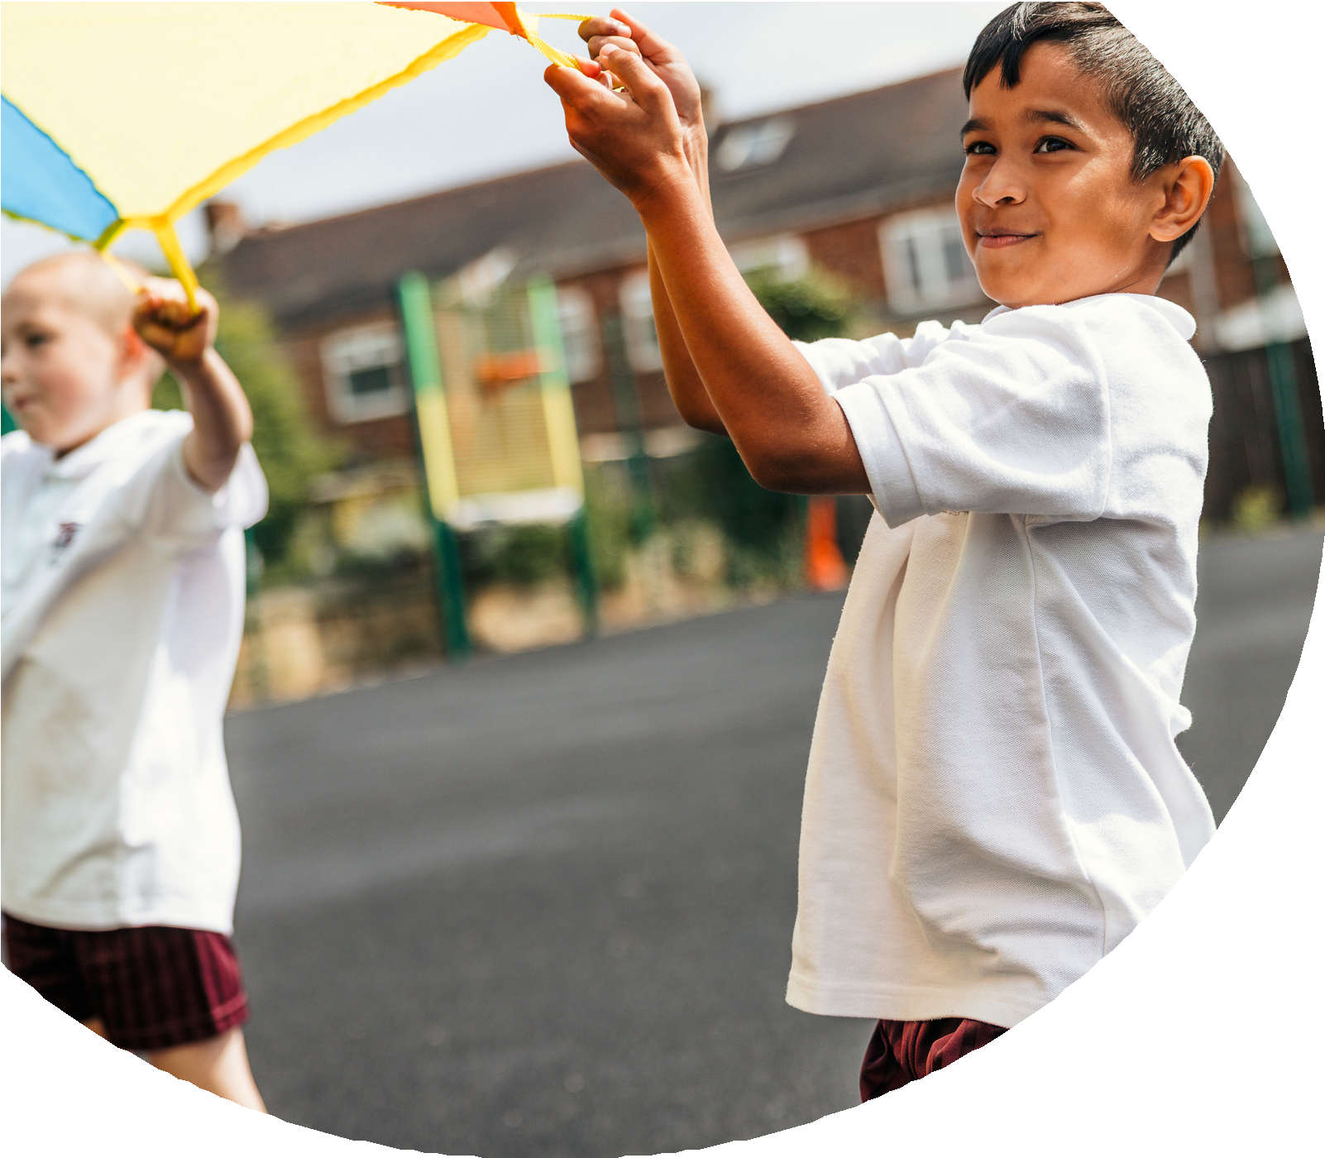
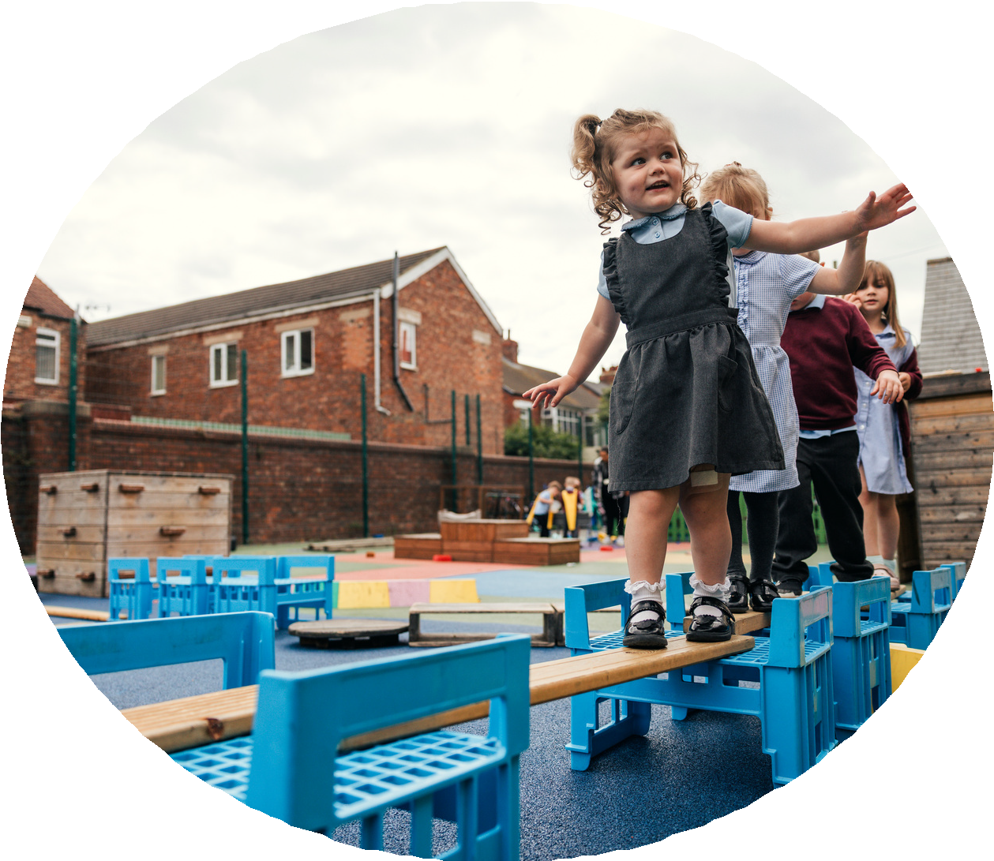

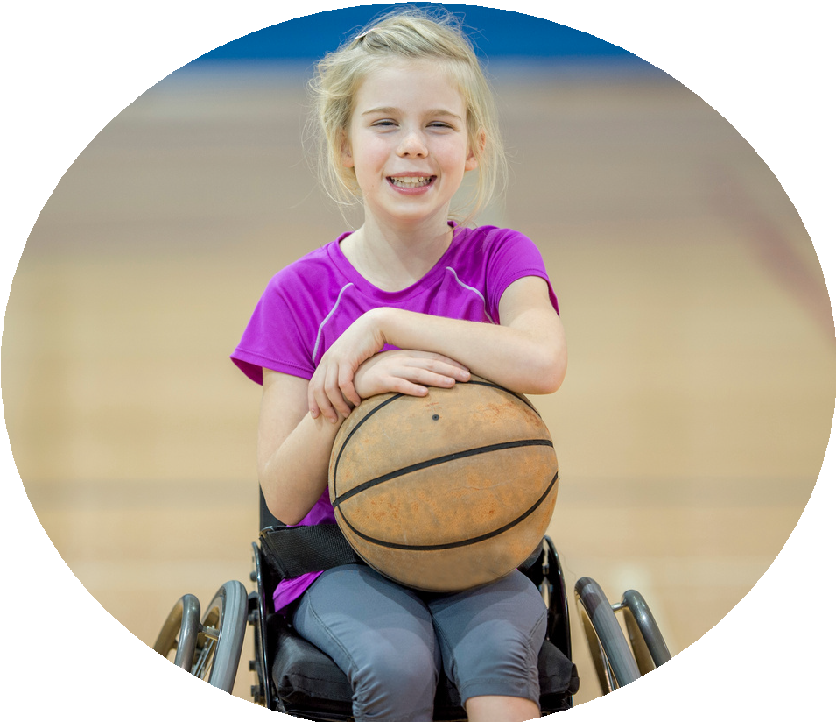



PE and sport premium monitoring and tracking form 2025/2026

Commissioned by

Created by


PE and sport premium monitoring and tracking form
- It is intended that this template should be used as preparation for the completion of the statutory DfE PE and sport premium digital expenditure reporting return. You can upload data (including swimming) from this template onto this platform once it becomes accessible.
- The template is a working document that you can amend and update during the year.
- Before you decide how you are going to use the funding for this academic year you should reflect and evaluate the impact of your use of you PE and sport premium funding in 2024/25.
- You should use your evaluation of last year’s funding to help you decide what to do this academic year, how you will do it, and what impact you expect it to have.
- All spending of the funding must conform with the terms outlined in the conditions of grant
- The summative digital expenditure reporting from June 2026 will continue to include swimming and water safety information. PE and sport premium funding can be used to provide top-up lessons, where necessary, to ensure pupils meet national curriculum swimming requirements
- To ensure funding is used effectively and based on your school’s needs; guidance and examples of best practice across schools can be found here.
- You must use the funding to make additional and sustainable improvements to the PE and sport in your school.
- You must develop and add to the PESSPA activities that your school already offers.

Useful Links:
- PE and sport premium for primary schools - GOV.UK
- PE and sport premium: conditions of grant 2025 to 2026 - GOV.UK
- It is intended that this template should be used as preparation for the completion of the statutory DfE PE and sport premium digital expenditure reporting return. You can upload data (including swimming) from this template onto this platform once it becomes accessible.
- The template is a working document that you can amend and update during the year.
- Before you decide how you are going to use the funding for this academic year you should reflect and evaluate the impact of your use of you PE and sport premium funding in 2024/25.
- You should use your evaluation of last year’s funding to help you decide what to do this academic year, how you will do it, and what impact you expect it to have.
- All spending of the funding must conform with the terms outlined in the conditions of grant
- The summative digital expenditure reporting from June 2026 will continue to include swimming and water safety information. PE and sport premium funding can be used to provide top-up lessons, where necessary, to ensure pupils meet national curriculum swimming requirements
- To ensure funding is used effectively and based on your school’s needs; guidance and examples of best practice across schools can be found here.
- You must use the funding to make additional and sustainable improvements to the PE and sport in your school.
- You must develop and add to the PESSPA activities that your school already offers.

Useful Links:
Complete the PE and sport premium expenditure reporting return - GOV.UK
PE and sport premium for primary schools - GOV.UK
PE and sport premium: conditions of grant 2024 to 2025 - GOV.UK

Review of the last academic year (2024/2025)

Swimming and Water Safety | What went well? Supporting evidence? | What didn't go well? Supporting evidence?
1. Swim competently, confidently and proficiently over a distance of at least 25 metres | 94% of children have achieved this target – assessment sheets from staff | Attendance of 2 pupils
2. Use a range of strokes effectively (for example, front crawl, backstroke and breaststroke) | 94% of children have achieved this target – assessment sheets from staff | Attendance of 2 pupils
3. Perform safe self-rescue in different water-based situations | 94% of children have achieved this target – assessment sheets from staff | Attendance of 2 pupils
- Take some time to reflect on your intent, implementation and impact from last academic year to celebrate your wins but to also think about improvements for the year ahead.
- You do not need to complete every box. Just record the information that is key to your school's priorities and areas of focus.
Remember - Be clear about how you focussed spending on key groups such as SEND, girls and disadvantaged pupils.

Review of the last academic year (2024/2025)
76% of our children took part in a sporting club throughout the year

High-quality PE lessons led by WSM staff - observed by SH – PE lead

100% of our children active for 60 mins a day

CPD delivered to all support staff for use of Forest School. All children working in the Forest School area to develop key skills – social interaction, independence, collaboration and confidence.

85% of our children have attended a sporting event through the Purbeck sporting partnership.

65% of our SEND children have attended a sporting event throughout the year.

Key areas as outlined in PE and sport premium guidance | What went well? Supporting evidence? | What didn't go well? Supporting evidence?
1. Increasing confidence, knowledge and skills of all staff in teaching PE and sporting activities prioritising CPD and training where needed | Lessons well planned and delivered – lesson observations from PE lead, planning looks from PE lead.  More children across school achieving EXP standard in PE (75%) DCPro | Some support staff needing more support to enable LA/SEN children to engage in lessons. Observed during lesson observations of PE lead.
2. Increasing engagement of all pupils in regular physical activity and sporting activities | 100% of children active across the week – Pupil voice  85% of our children take part in a sporting event across the year – lists of participants of events.  64% of school take part in a club at some point during the year. – club registers. | Some children are not able to attend sports events due to parental reasons and some simply don’t want to compete/work with other children from other schools.  SEN children take part but some are unable to due to high-needs and being able to cope with events -alternatives are offered within school.  Reception do not take part in after school clubs in their first year. due to ensuring they settle in to school before introducing a club. They also tend to be very tired when they first start school. We offer a lunchtime club for them to attend if they wish to begin to integrate them with the rest of the school starting in the spring term.
3. Raising the profile of PE and sport across the school, to support whole school improvement | We have taken part in many events against other schools as part of the Purbeck Partnership.  We have run a sports day which encompasses competitive and non-competitive events.
4. Offer a broader and more equal experience of a range of sports and physical activities to all pupils and ensure equal access to sport for boys and girls | Clubs offered to all both sexes – no single sex clubs.  Uptake from both girls and boys is good with more KS2 children taking part than KS1.  Children for sports events are picked with an even number of girls and boys selected for the events. | Class lists - for sports events.  Clubs lists
5. Increasing participation in competitive sport | The pathways competitions have been attended by 25% of the school - mainly boys/girls football. | We didn’t attend the athletics pathway as children were not as confident and we felt the outcome would not be encouraging for them. This is a development for this academic year. We have out in place a weekly lunchtime session with a sports TA who will prepare the children for their events.

Aims for the next academic year (2025/2026)
- Using your whole school priorities, school development plan and previous PE, school sport and physical activity data, set out your aims for the year ahead.
- Think about specific areas of need such as inactive girls, SEND and disadvantaged pupils
- Remember to also input your swimming data and reflections in the table located at the bottom of this page.
- Consider which of the 5 key areas improvements will be focussing on:
- Increasing confidence, knowledge and skills of all staff in teaching PE and sporting activities prioritising CPD and training where needed.
- Increasing engagement of all pupils in regular physical activity and sporting activities
- Raising the profile of PE and sport across the school, to support whole school improvement
- Offer a broader and more equal experience of a range of sports and physical activities to all pupils and ensure equal access to sport for boys and girls
- Increasing participation in competitive sport
Swimming and Water Safety | Input data | Reflections
1. Swim competently, confidently and proficiently over a distance  of at least 25 metres | 90% | One child who regularly didn’t attend school on swimming days did not achieve the competency.
2. Use a range of strokes effectively  (for example, front crawl, backstroke and breaststroke) | 90% | One child who regularly didn’t attend school on swimming days did not achieve the competency
3. Perform safe self-rescue in different water-based situations | 90% | One child who regularly didn’t attend school on swimming days did not achieve the competency

Aim | Why? | Key area | Supporting evidence
- To ensure we apply a strong offer of inclusive extra-curricular sports clubs for all pupils to take part in. | We believe all children should have the opportunity to high quality sports clubs free of charge.  Pupil with additional needs should be able to take part in a club of their choice. | Number 2 - Increasing engagement of all pupils in regular physical activity and sporting activities  Number 4 - Offer a broader and more equal experience of a range of sports and physical activities to all pupils and ensure equal access to sport for boys and girls | 68% of our pupils took part in a sports club with some pupil taking part in more than one. (clubs tracker updated weekly)  Clubs ranged from football, netball, basketball, handball, athletics, tennis and multi skills.  Clubs were run by teachers, sports coach, external leaders and parents.
- To use a female, skilled sports coach to upskill teachers and HLTAs with a focus on developing the confidence of KS2 girls in PE. | Girls historcially have not had the same enthusiasm for PE as boys. By working with a female sports coach provides our children with a positive role model and one who plays Ladies’ football to a high level.  We want to develop confidence in all our children and by using a coach to help support our staff, this will ensure all children are supported and encouraged appropriately in PE. | Number 1 -Increasing confidence, knowledge and skills of all staff in teaching PE and sporting activities prioritising CPD and training where needed. | Our female sports coach supported staff in lessons and modelled activities supported LA girls in PE lessons.  50% more girls in KS2 were achieving N in PE than this time last year. Assessment data reflects this improvement.
- To use a sports coach to work with children who do not participate in a club to enhance their ability. | We have found some children do not enjoy taking part in after-school clubs or sporting events every week. We want to ensure these children are still able to fulfill their potential and by working in a smaller group with our coach, this will develop their confidence and ability. | Number 2 - Increasing engagement of all pupils in regular physical activity and sporting activities | Our sports coach planned activities for lunchtimes designed to support those children who did not regulary take part in clubs  The PE lead identified the children ( using clubs data) who had not signed up for a club and the sports coach worked with them at lunchtimes. Bronze Ambassadors were also used to support groups of children to build confidence and skills (Bronze Ambassador leadership programme support young leaders to develop skills and ways to support other children). Activities such as handball, football, tennis, multi skills, team games, atheltics and rounders were planned for.
- To ensure all children have the opportunity to take part in a competitive/non-competitive event depending on ability/need/confidence level. | We have seen from evidence over the last 4 years that children who compete competitively have a more postive attitude towards their learning. (pupl voice) We want all children to experience this and therefore would like all children to have the opportunity to take part in competitive events.  For those children who do not like competition, we feel the non-competitive events meet their need by giving them the additional confidence and support from older children in achieving skills and taking part in games. | Number 2 -Increasing engagement of all pupils in regular physical activity and sporting activities  Number 4 - Offer a broader and more equal experience of a range of sports and physical activities to all pupils and ensure equal access to sport for boys and girls  Number 5 - Increasing participation in competitive sport | We ensured that every child in the school had the opportunity to take part in a sporting event at the Purbeck School. 90% of the school (Y1-Y6) took part in an event (attendance register kept for each event and tracked to ensure all children were invited to take part) – out of the 10% who didn’t, the children did not want to take part or were poorly on their event day.
To ensure all disadvantaged children have the opportunity to take part in a sporting event. | We have noticed that not all our disadvantaged pupils are able to take part in sporting events for various reasons. We want to ensure all of our disadvantaged pupils have the opportunity to take part and achieve in some way.  We also want to ensure our vulnerable children have priority at afer-school sporting clubs. | Number 2 - Increasing engagement of all pupils in regular physical activity and sporting activities | We priotised our disadvantaged children when selecting children for sporting activities. (PP lead identifid vulnerable children who should be given priority) 90% of the children took part and were given sports kit to wear if necessary.  The remainining 10% chose not to attend.  68% of our disadvantaged children from Y1-Y6 took part in after school clubs.
Aims for the next academic year (2025/2026)

Plan, monitor and evaluate (2025/2026)
- Please aim to use this as a live working document through the year.

- Keep returning to this to evidence adaptations and progress made through the PESSPA opportunities you provide.

- There is no set number of objectives you must have.

- Make as many or as few as you see fit that will support your aims for the year ahead.

- Consider which of the 5 key areas improvements will be focussing on:
- Increasing confidence, knowledge and skills of all staff in teaching PE and sporting activities prioritising CPD and training where needed.
- Increasing engagement of all pupils in regular physical activity and sporting activities
- Raising the profile of PE and sport across the school, to support whole school improvement
- Offer a broader and more equal experience of a range of sports and physical activities to all pupils and ensure equal access to sport for boys and girls
- Increasing participation in competitive sport

Plan, monitor and evaluate (2025/2026)

Example objective shown below is for reference purposes only:
 | Intent – what is your objective? | Implementation - How will you achieve this? | Impact - What do you hope to see? | Supporting evidence
Plan and monitor | Develop lunchtime play provision to increase activity for least active groups. | Develop pupil leadership (training programme), Midday supervisor training, Staff CDP to develop their understanding of games and play, Range of equipment, Youth voice activities to understand pupils wants and needs Outdoor play provision such as OPAL | A confident and competent group of activity leaders that take initiative and create a more active and inclusive playground for all pupils. Midday supervisors and all staff leading a range of physical activities and joining in with movement daily to role model. A happier, more active playground that meets the needs of all pupils especially SEND and girls. | Youth voice data through half-termly surveys and interviews/group discussions with a variety of pupils (leaders, children participating and those that are less active at break times). Conduct regular observations of the playground to gauge activity levels of the least active children. Staff voice and feedback
 | What impact have you seen? | Are the improvements sustainable? How? | Supporting evidence | Approx. cost
Evaluate | Activity leaders are leading a broad range of activities and actively seeking children that are not engaged in physical activity during lunch times. Midday supervisors have grown in confidence and far more active and engaged in games with the children. Lunch times are more active with children having fun. Activity options have been tailored to suit the needs of SEND pupils through considerate choices of equipment and the types of games played. Girls are proving to be the hardest group to engage as some are still choosing not to be active | Continued training for activity leaders and bringing new leaders into the group to bring new ideas and expertise. More leaders will also mean more activities are able to be delivered. Continued training with midday supervisors. Establish lead midday supervisors to empower them and give them ownership. Continue to listen to SEND pupils and tailor activities to their needs and wants. Focus priorities on engaging girls. Work with least active girls to create activities that are meaningful and enjoyable for them. Do they want to be activity leaders for younger children to give them purpose and confidence? | 100 out of 100 activity leaders want to carry on with this role next year. 30 more children have enquired to joining the team. Meetings and the end of year survey have shown all leaders feel positive and enjoy making a difference for others. Interviews by random selection were conducted and 92% of pupils were either 'happy' or 'very happy' with the activities on offer at lunch time. End of year physical activity survey findings such as:  - Am I involved with games at lunch time - 89% Yes  - Do I enjoy lunch time? 97% Yes  - Have I joined in with a game with the activity leaders? 100% Yes | Physical Resources - £1000  CPD for staff - £500  OPAL - £8000
Your Objective:

- To ensure we apply a strong offer of inclusive extra-curricular sports clubs for all pupils to take part in.

 | Intent – what is your objective? | Implementation - How will you achieve this? | Impact - What do you hope to see? | Supporting evidence
Plan and monitor

 | What impact have you seen? | Are the improvements sustainable? How? | Supporting evidence | Approx. cost
Evaluate

Your Objective:

 | Intent – what is your objective? | Implementation - How will you achieve this? | Impact - What do you hope to see? | Supporting evidence
Plan and monitor

 | What impact have you seen? | Are the improvements sustainable? How? | Supporting evidence | Approx. cost
Evaluate

Your Objective:
 | Intent – what is your objective? | Implementation - How will you achieve this? | Impact - What do you hope to see? | Supporting evidence
Plan and monitor

 | What impact have you seen? | Are the improvements sustainable? How? | Supporting evidence | Approx. cost
Evaluate

Your Objective:
 | Intent – what is your objective? | Implementation - How will you achieve this? | Impact - What do you hope to see? | Supporting evidence
Plan and monitor

 | What impact have you seen? | Are the improvements sustainable? How? | Supporting evidence | Approx. cost
Evaluate

Your Objective:

 | Intent – what is your objective? | Implementation - How will you achieve this? | Impact - What do you hope to see? | Supporting evidence
Plan and monitor

 | What impact have you seen? | Are the improvements sustainable? How? | Supporting evidence | Approx. cost
Evaluate

This page has been left blank for any notes or supporting information.

